**Google Chrome**

Export the SSL certificate of a website using Google Chrome:

1.Click the ***Secure*** button (a padlock) in an address bar.

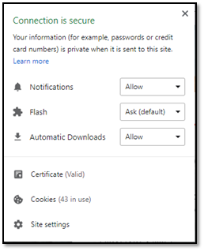

2. Click the ***Certificate(Valid)***.

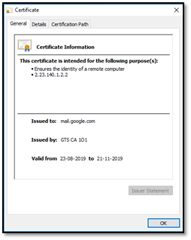

3. Go to the ***Details*** tab

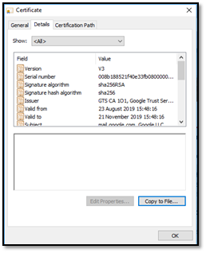

4.Click the ***Copy to File…*** button

5.Click the ***Next*** button.

6.Select the “Base-64 encoded X.509 (.CER)” format and click the ***Next*** button.

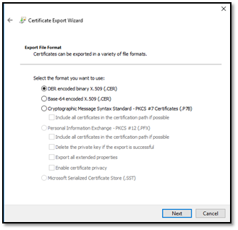

7.Specify the name of the file you want to save the SSL certificate to

8.Click the ***Next*** and the ***Finish*** buttons

**Mozilla Firefox**

Export the SSL certificate of a website using Mozilla Firefox:

1.Click the ***Site Identity*** button (a padlock) in an address bar.

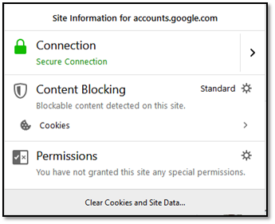

2.Click the ***Show connection details*** arrow

3.Click the ***More Information*** button

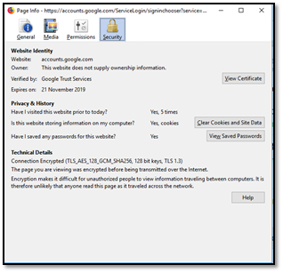

4.Click the ***View Certificate*** button

5.Go to the ***Details*** tab

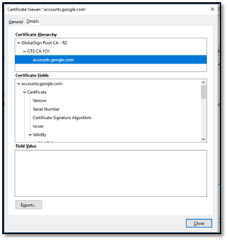

6.Click the ***Export*** button

7.Specify the name of the file you want to save the SSL certificate to, keep the “X.509 Certificate (PEM)” format and click the ***Save*** button

**Internet Explorer**

Download and save the SSL certificate of a website using Internet Explorer:

1.Click the ***Security report*** button (a padlock) in an address bar

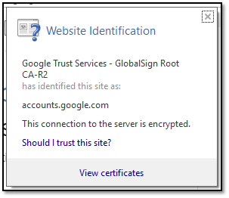

2.Click the View Certificate button

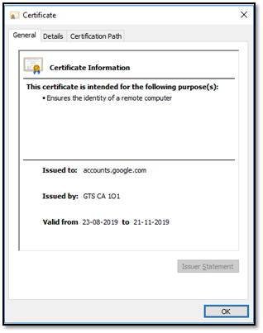

3.Go to the ***Details*** tab

4.Click the***Copy to File***… button

5.Click the ***Next***button

6.Select the “Base-64 encoded X.509 (.CER)” format and click the ***Next*** button

7.Specify the name of the file you want to save the SSL certificate to

8.Click the ***Next*** and the ***Finish*** buttons

**OpenSSL**

Get the SSL certificates of a website using openssl command :

$ echo | openssl s_client -servername **NAME** -connect **HOST:PORT** |\

sed -ne ‘/-BEGIN CERTIFICATE-/,/-END CERTIFICATE-/p’ > certificate.crt

**Explanation :**

>>**connect HOST:PORT** :- The host and port to connect to

>>**server name NAME** :- The TLS SNI (Server Name Indication) extension (website)

>>**certificate.crt** :- Save SSL certificate to this file

**Example**:

$ echo | openssl s_client -servername google.com -connect google.com:443|\

sed -ne ‘/-BEGIN CERTIFICATE-/,/-END CERTIFICATE-/p’ > certificate.crt